Total No. of Questions: 8 Seat No.

SE/PRELIM/MAY –23

**B.E. (Computer Engineering)**

Deep LEarning (2019 Pattern) (Semester - I) (410251)

Time :2 1/2 Hour] [Max. Marks: 70]

Instructions to the candidates:

1. All questions are compulsory.
2. Figures to the right indicate full marks.
3. Assume suitable data wherever necessary.
4. Draw Neat diagrams wherever necessary.

Q.1 Explain CNN architecture with the help of diagram [9]

Q.2 Explain Local Response Normalization [8]

Q.3 Explain Generative Adversarial Network (GAN) with diagram [8]

Q.4 List and explain GAN models [10]

Q.5 Explain Markavo Decision Process [10]

Q.6 Compare Generative and Discriminative Model [7]

Q.7 Explain Deep Q-Learning network and list its advantages [8]

Q.8 Make use of Dynamic programming algorithm to solve Grid world game gien as below [10]

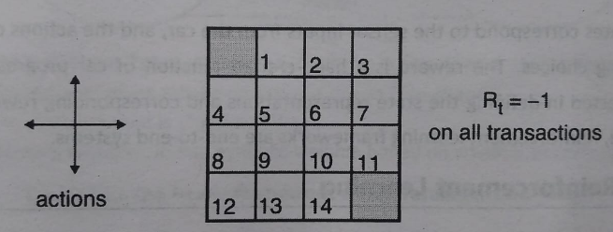

**\*\*\*\*\*\* All The Best \*\*\*\*\*\***